Lesson 3:
Making a GREAT start in Beekeeping

Their new home….and getting ready to be a beekeeper
- Decide on the size of equipment/boxes to be used.
- New or Used Equipment
- Purchase and build as needed
- Paint it and set it in place before you get bees!
- Practice in your suit and gloves
- Lighting the smoker…gather fuel (burlap, pine needles/cones, wood shavings) no ink, bar-b-q coal or lighter fluids…Be careful and don’t set a fire! When done-Cork it.
- Walk to and around the apiary
- Carry toolbox

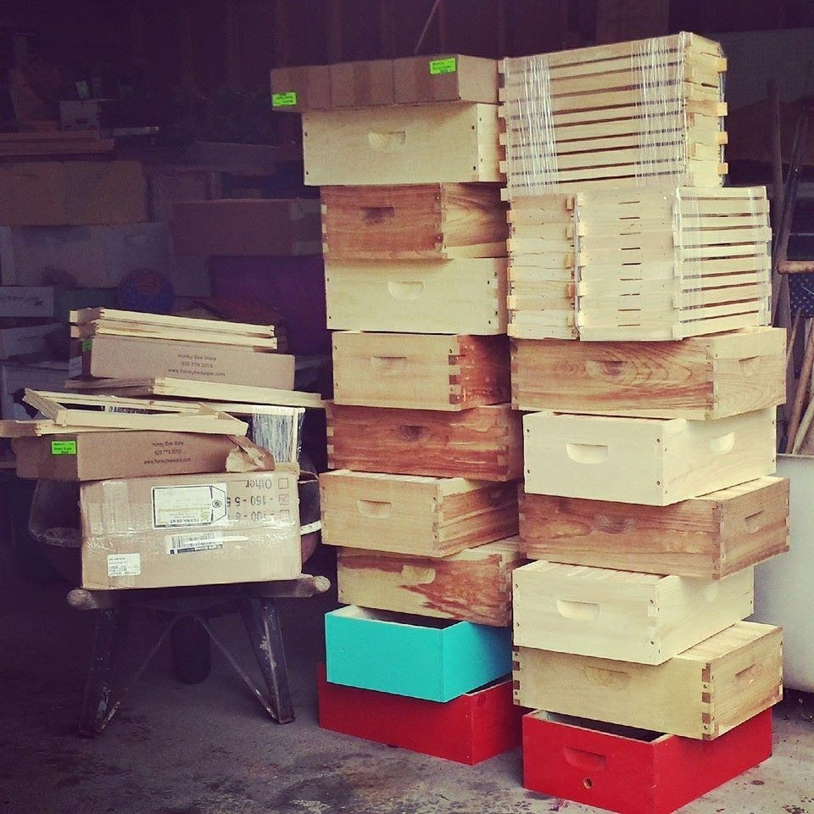

Hive/Apiary Location is important:
Location, Location, Location
- Accessible
- Vehicle
- Heaviness of everything beekeeping
- Good footing
- Sunny spot
- Protected from wind/storms
- Dry/air movement…Wet bees are dead bees!
- RCW’s for your town/county
- Neighboring fence lines and flight lines
- Roads
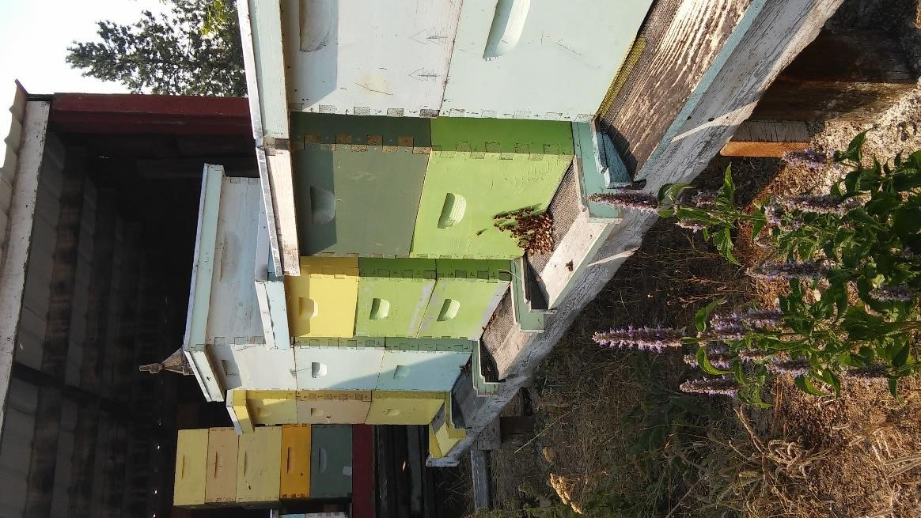
- Apiary fencing/yards/warning signs
- Livestock
- Pets
- Bears, Badgers
- Hive arrangement
- South by South-East tilted slightly forward
- Paired up on pallets, blocks, or stands to work from the sides
- Hives in a straight line that look too much alike will incur more drift
- High enough to prevent pest, low enough to prevent strained back muscles

Buying Honeybees:
Carniolans, Italians, Caucasians
- Find out what honeybees are available in your area
- Suppliers- local and Not local
- Order NOW! Package day is April_______
- The Nucleus hive, The Package, Established hive, Swarms

The Nucleus Hive
- Often harder to find supplied
- More $$$
- Later in April/May
The Pros of getting a Nuc:
- Laying Queen, mother of the cluster
- 5 drawn frames
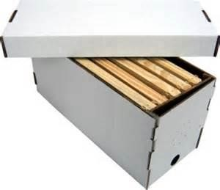
- Brood and food frames

- Easy installation
The Cons of getting a Nuc:
- How old is the Queen, really?
- Old diseased/poisoned comb
- Mites

The Package
- Available through several local suppliers
- Package day is April_____, trucked here from Northern CA.
- 3 pound package contains 10,500 bees (or more), 1 Queen, can of syrup
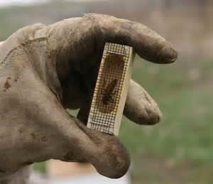
The Pros of getting a Package:
- Marked New Queen
- Recently treated for mites
- A little less $$$

The Cons of getting a Package:
- Not a proven Queen
- Not their mother
- Need to build comb before she can lay
- Packaging and shipping of the package
- Installation is a bit more tricky

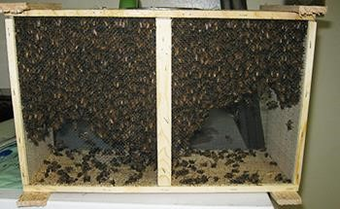

The Established Hive
- Availability is low
- Any time of year

The Pros of getting an Established Hive:
- Proven Queen
- Drawn frames
- Pollination and Honey….now
- No installation
The Cons of getting an Established Hive:
- Know the beekeeper! How have these bees been treated?
- Diseased?
- Moving a full hive
- $$$$$$$$

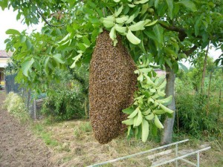
Free bees…The Swarm!
- Install like a package

Package Day: Working the bees for the first time
- Where your protective suit, shoes, hair ties
- Act/look like a bear…get treated like a bear
- Show up in the right frame of mind
- Work the hive between 10am and 4pm on a warm (55*F +), sunny day (no wind!)
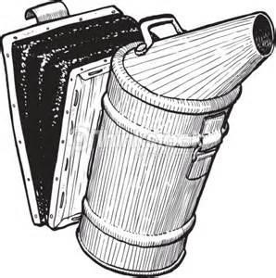
- ½ the hive is out foraging
- Light up the smoker
- A little smoke goes a long way
- Say hello and puff the front door
- Under the lid
- A little across the top of the frames…don’t smoke them out!
- Fewer smashed bees when moving the frames
- Stings will probably happen…sooner or later
- Scrape the stinger out before all the venom is released
- Minor - Serious -Dangerous reactions to venom

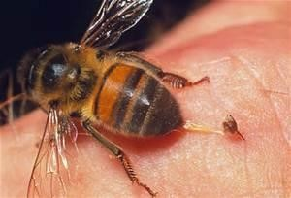

Installation of 5 frame Nucs into a hive:
- Pick up Nuc from supplier, remove bees from outside, cover with a dish towel
- Place in secure position in car, away from heater/cooler venting
- At home, if waiting on weather/etc place in a dark room (50*F+), covered loosely—pets/kids!
- Warm-ish day, no wind, no rain/sleet/snow, later in the afternoon
- Open new hive box, and remove 6 frames; set aside.
- Insert frame feeder into the 1st frame or 8th/10th frame position
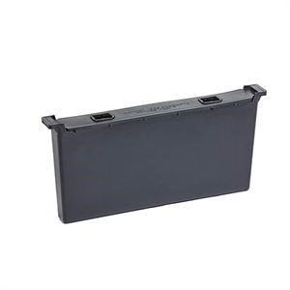
- Fill feeder with 1:1 syrup-warm
- Cane or beet sugar stirred into hot water until clear, never boiled
- Fill feeder only ½ way
- Place an empty frame next to the feeder – insulation
- Place the Nuc next to the hive
- Open lid of Nuc and very lightly puff a little smoke across the top of the frames so that you can lift them out without squishing bees.
- Starting on one end, gently/slowly lift and move a frame and bees from the Nuc to the hive box, placing it in the third position.
- Follow with each of the remaining four frames, lightly smoke as needed.
- Carefully replace remaining empty frames to fill box
- Smoke and/or brush the bees from the edges of the box, replace lid.
- Reduce entrance of hive

Installation of a Package into a hive:
- Pick up package from supplier, remove bees from outside, cover with a dish towel
- Place in secure position in car, away from heater/cooler venting
- At home, if waiting on weather/etc place in a dark room (50*F+), covered loosely—pets/kids!
- Warm-ish day, no wind, no rain/sleet/snow, later in the afternoon
- Open new hive box, and remove 6-7 frames; set aside.
- Insert frame feeder into the 1st frame or 8th/10 frame position
- Fill feeder with 1:1 syrup-warm
- Cane or beet sugar stirred into hot water until clear, never boiled
- Fill feeder only ½ way
- Place an empty frame next to the feeder-insulation
- Place the Package next to the hive
- Shake or lightly rap the package so that the bees fall to the
bottom of the cage, remove the syrup can – slide the Queen cage out and replace can to cover hole – keeping most of the bees in the package.
- You may need to gently knock bees off the outside of the Queen cage.
- Remove cork (I like to use a diaper sized safety pin) from the end of the Queen cage and carefully replace with a small portion of marshmallow.
- This is all done much easier with bare hands
- Hang the Queen cage between the second and third frames…may use a little tape on top of frame. Make sure Queen cage is turned so she can breathe! Worker bees will eat out the marshmallow in the next couple of days to release her.
- Remove syrup can from package and invert package, pouring bees into the opening between frames. You may need to gently rap the package to better clump and pour the bees several times.
- Place the package with any remaining bees leaning against the front entrance of the hive, hole upward.
- Carefully fill box with remaining frames.
- Smoke and/or brush bees from the edges of the box and replace lid.
- Reduce entrance of hive

Be Patient! Let the bees settle into their new home.
1st Check
3 days or so after installation, (weather permitting) check the feeder and refill ½ way with warm syrup as needed – by removing the lid, slide the inner cover (if using) just to expose the feeder for checking.
After checking the syrup, slide the cover over a few more inches and gently push the frames sandwiching the Queen cage apart. Look to see if the Queen has been released. She should be. If not, remove the last frame making space to then remove the Queen cage and check for any obstructions near the marshmallow. Remove obstruction, keeping cage near the tops of the frames and allow the Queen to be released between frames. Gently replace and reposition all frames.
2nd check
Continue to be patient. Refill syrup (as above) every three days or so…but don’t open the hive completely.
3rd check
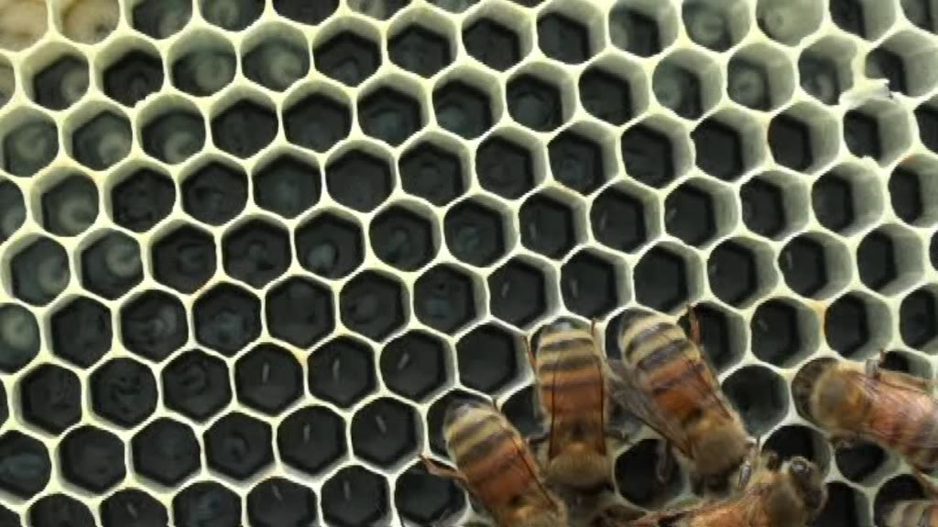
Wait a week+ from the time the Queen was released before inspecting the frames for drawn comb or brood (eggs/larvae). Hopefully the Queen is laying eggs by now. If you don’t see them, look for her. Your goal here is to see one or the other or both (Queen right).

4th , 5th, 6th check, etc –goal
Continue feeding syrup to the bees (as above) until 70-80% of the frames of the box are fully drawn comb.
At that point, remove the feeder and replace it with an empty frame. Place a second box above the first.
Place the feeder in the 1st frame position of the second box. Fill the rest of the box with empty frames.
Continue feeding syrup until the bees draw out 70-80% of the second box of frames; or until they discontinue feeding from the syrup (nectar flow may be on).
Remove the feeder and replace with a frame. It can take 20-40 pounds of sugar over the course of this time to properly start a colony.

Inspect the frames for drawn comb, brood, and the Queen no more than once a week.

Nectar Flow
Discontinue feeding
Add honey super, allowing to draw out with comb and fill with nectar/honey to 60-70% before adding more supers, one at a time.

